Administrators Training Manual for Regularly Scheduled Series (RSS)

April 2019

TABLE OF CONTENTS

Introduction 3
Benefits of the RSS Dashboard 3
RSS Coordinators/Owners Set Up 4
Create RSS Coordinator/Owner Accounts 4
RSS Coordinator/Owner User Screen Access via Templates 5
Entering a New RSS Activity (The Parent) 10
Auto-Generating RSS Sessions (The Children) 13
Approving RSS Child Activities 15
RSS Dashboard 15
Case Conferences 19
RSS Icons 22
RSS Status Definitions 24
COI Resolution Form 24
Peer Reviewers (PR) 25
Activity Manager - Peer Reviewer (Best Practice) 25
Membership Manager - Peer Reviewer 26
Summary 26

Introduction

You have been nominated in the role of RSS Coordinator for the department. CPD Office staff have provided you with RSS Coordinator access. Once you have registered on Cloud CME you are able to log in anytime to add further sessions to the activities for which you have been nominated as the owner.

At Sidra, RSS are educational rounds, journal clubs, workshops, simulation training. Sometimes the content of the sessions is repeated but at other times there are changes in regard to presenters, content, and learning outcomes.

As RSS Coordinator you can complete details such as topic title, faculty, disclosure collection, and handouts. When you as the coordinator completes these steps, our CPD Office can then approve the individual session, assuming all documentation is complete.
In CloudCME®, Regularly Scheduled Series management has five steps.

- Create the overall RSS activity, typically via a submitted application. This is referred to as the parent activity for the series. CPD OFFICE
- Setup recurrence. Recurrence is the frequency that the activity repeats (i.e. weekly, every 3rd Wednesday, etc.). CPD OFFICE
- Generate child activities (sessions). Children inherit the general information such as title, description, etc. from the parent. Their dates/times are based on the recurrence settings. CPD OFFICE
- Assign the RSS Coordinator/Owner. Ownership in CloudCME® ensures that the RSS Coordinators/Owners work only with specific activities. An Administrator might see all activities in the system, whereas an RSS Coordinator/Owner would see only those activities they have been assigned and no others. CPD OFFICE
- Approve the child activities (sessions). CPD OFFICE

Benefits of the RSS Dashboard
- View all child activity information on one screen
- Verify that upcoming RSS activities have all documentation in place
- Add faculty to the RSS child activity and auto-assign a disclosure without navigating to Faculty Management
- Begin Conflict of Interest Resolution process, if needed
- Generate a flyer for the activity and export to PDF/Word
- Email coordinators or faculty
- Approve the activity

RSS Coordinator/Owner User Screen Access via Templates
After you create accounts for RSS Coordinators/Owners, you next want to limit their access within CloudCME®. CloudCME® recommends creating a User Screen Access template when providing screen access to RSS Coordinators/Owners. Creating a template for RSS Coordinators/Owners requires a one-time action to select specific functionality sections and/or individual screen access. Once you create the template, you can bulk import many RSS Coordinators/Owners in one import file and assign the User Screen Access Template to those users in the import file. This is useful when multiple users should have the same access to sections or screens within the administrative side of the system.
Sidra IT Support – Dharma Natarajan – dnatarajan@sidra.org

Auto-Generating RSS Sessions (The Children)

Select the “Date/Time” tab. When creating RSS activities, both the Start and End Date for the activity must be the first day the activity will be held. Enter the date and correct time in both fields.

Set the appropriate TimeZone, “Allow Texting Minutes Prior” and “Allow Texting Minutes After” and click the Update button.

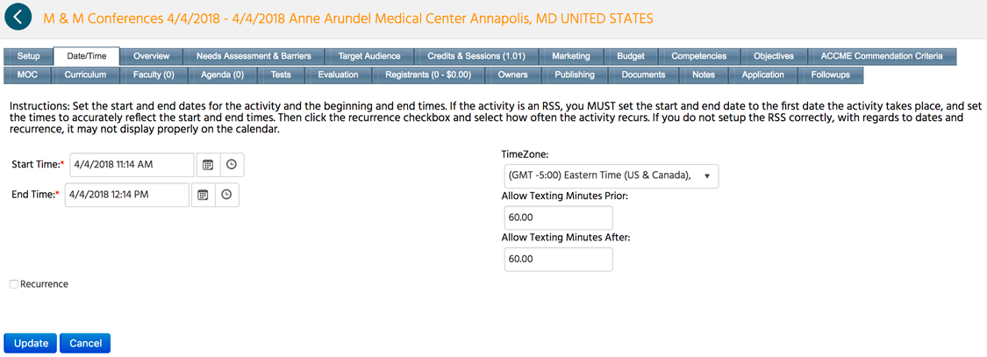

Next, check the “Recurrence” box, set the frequency of the RSS activity, and click the Update button.

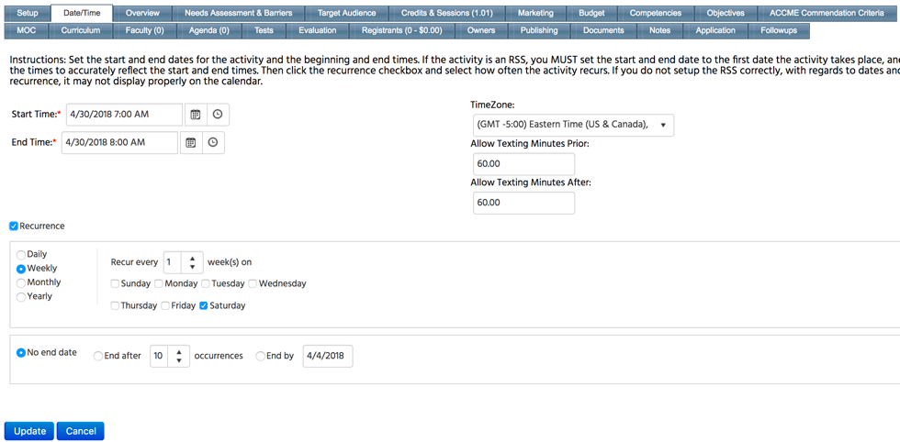

When the screen refreshes, an Auto-Generate Child Activities button will display. You will see “Children Inherit Objectives”, “Children Inherit Faculty”, “Children Inherit Faculty Tasks” and “There is no primary evaluation set, so you cannot automatically create evaluations for children” checkboxes.

If any of these checkboxes are selected in the RSS parent within Activity Manager, this information will carry down to the RSS child upon auto-generating child activities. If you would like an evaluation carried down to all child activities, on the Forms screen next to the evaluation, you must select the “Primary Eval” checkbox to associate the evaluation to all the child activities.

To create the child activities, click the Auto-Generate Child Activities button.

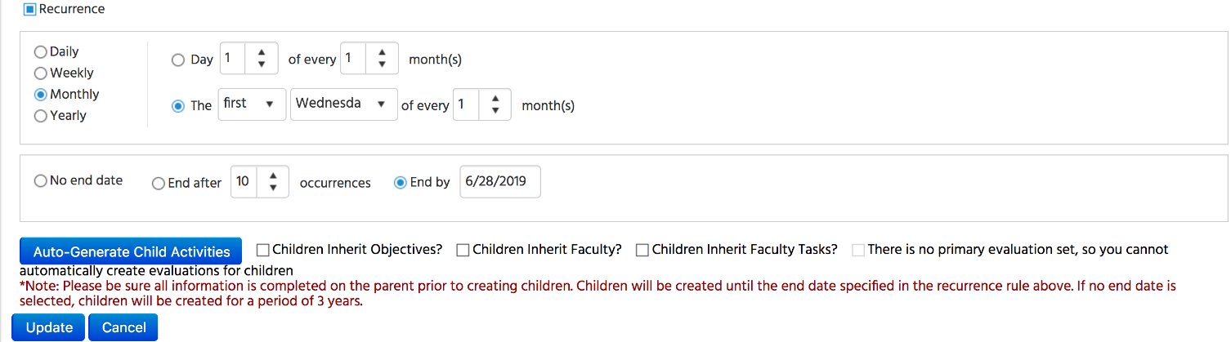

This will create the RSS child activities per the frequency selected. A message will display informing how many children the system created for the RSS activity. Initially, the child activities will inherit the parent name and additional details until the child activities are updated in the RSS Dashboard by the RSS Coordinator/Owner.
Click the Update button to save your selections made on this screen.

NOTE: If you do not click the Update button, you will have to complete the process on this screen again.

Approving RSS Child Activities

In CloudCME®, RSS Coordinators cannot approve RSS child activities. An Administrator must approve the RSS child activities, this will be the CPD Office. We will approve the session if the details are correct, all dates must be accredited before being added. Additional dates must be reported to the QCHP at least 2 weeks beforehand. If a session has been cancelled then the date will need to be removed.

RSS Dashboard

The dashboard is where RSS Coordinators/Owners will work on their assigned child activities and where you will review and approve those activities. Access the dashboard by selecting Activities > RSS Dashboard from the main menu in CloudCME®.

For Administrators, the default status when initially navigating to the RSS Dashboard is Pending. (Please see the RSS Status Definitions section below for a definition of each status). The dashboard will list all activities sorted by date. You can use activity title, frequency, and date range to narrow the child activities listing. Alternately, you can use the Status, Owner, or Administrator fields to locate a specific RSS session. Searching by Owner or Administrators will display those activities assigned to users with that role.

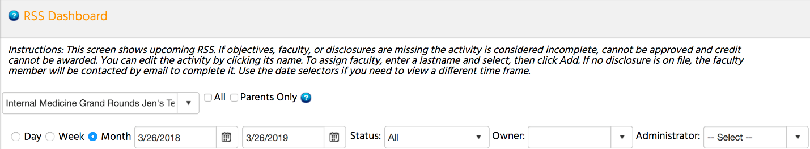

Child activities should be topic-titled by the Coordinator so that the topic name, rather than the overall parent name, will appear. Those topic titles will appear in users’ transcripts after attendance is recorded. For this reason, the child activity title should be reviewed.

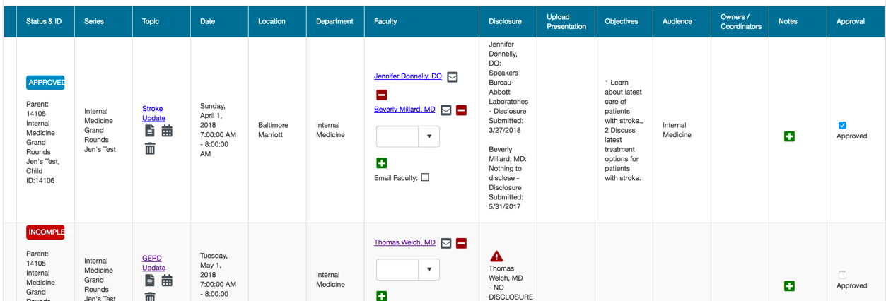

After clicking the title, a new screen will display allowing you to review the RSS child activity information. If you make any changes to this information, be sure to click the Save button located at the bottom of the screen.

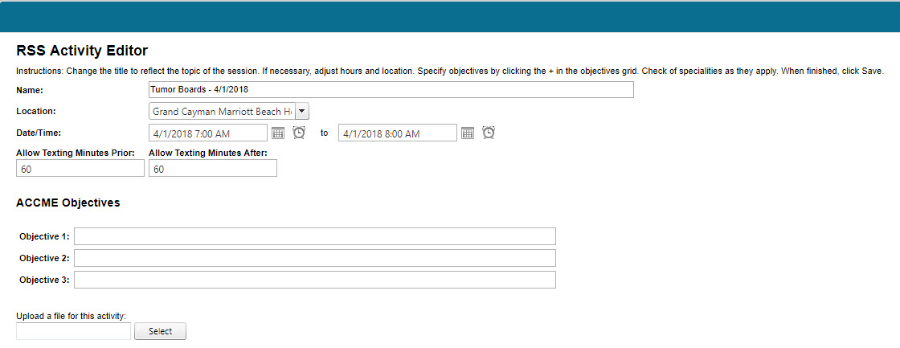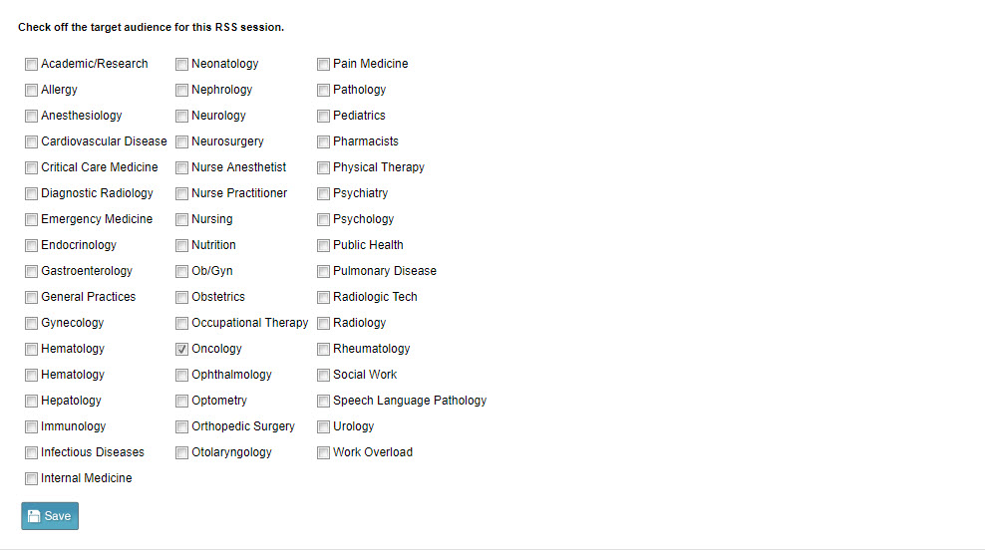

Once your review is complete, click the X at the top of the screen to return to the RSS Dashboard.

The dashboard grid will contain the correct title, location, objectives, faculty, and a completed disclosure. You cannot approve an activity if no faculty are specified or, if faculty are specified, but they have not completed their disclosure.

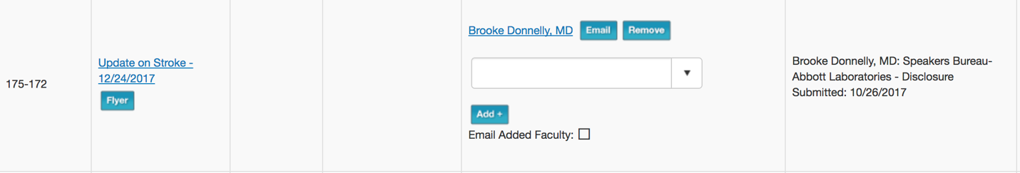

A Notes column is available to Activity Administrators. Peer reviewer notes and ad hoc notes can be viewed. Notes entered will be recorded on the Notes tab within the activity record in Activity Manager. For searching purposes, notes are type ‘Application.’
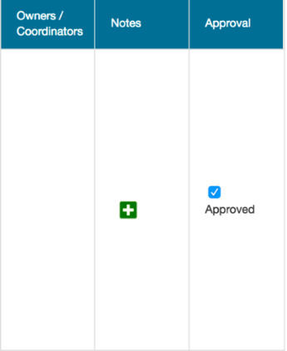
Once your review of the child activity is complete, you may approve the child activity by clicking on the “Approved” checkbox in the “Approved?” column on the right-hand side of the screen. Marking the child activity as Approved changes the status to Complete.

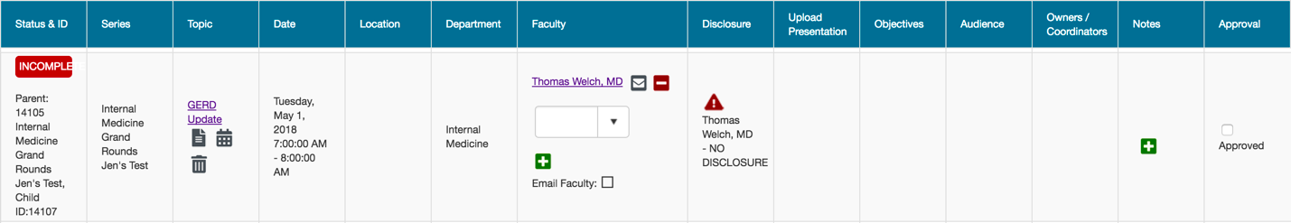

Emails can be sent to the RSS Coordinator/Owner instructing them to make additional changes or inform them their activity is in approved status. To send an email to the RSS Coordinator/Owner, click on the RSS Coordinator’s/Owner’s name in the Owners/Coordinators column. An email screen will appear to write the email message.

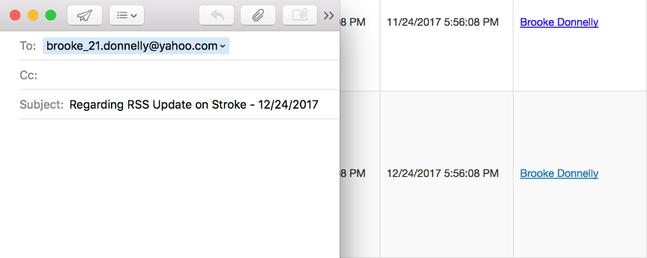

Case Conferences

If the Regularly Scheduled Series is a case conference (i.e. tumor boards, M & M conferences), and when the Update button is clicked on the Setup tab, a new question will display below the Type field, “Is this a Case Conference?” Select this checkbox and click Update on the Setup tab.

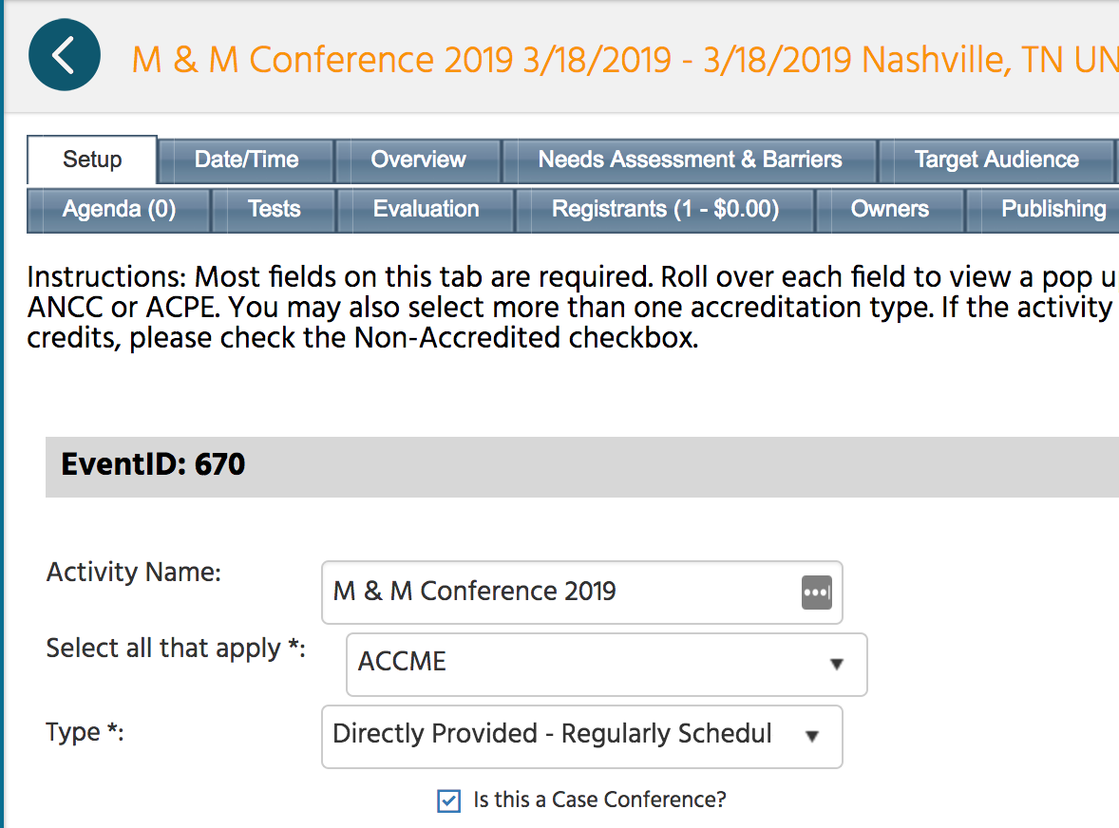

The RSS Coordinator/Owner can click on the dropdown list in the Faculty column in the RSS Dashboard. The dropdown list populates with the faculty assigned to the RSS parent.

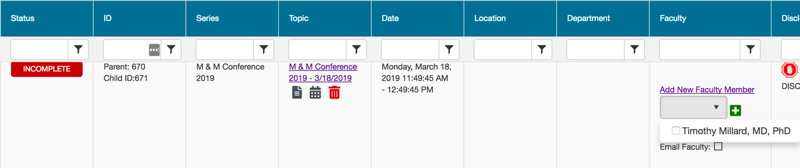

The RSS Coordinator/Owner can select the faculty member from the dropdown list and click the green + button.
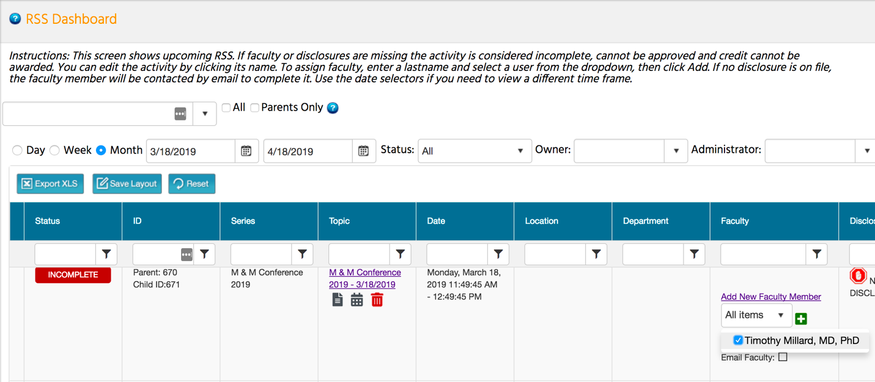

When the screen refreshes, the selected faculty member will be added to the child activity.

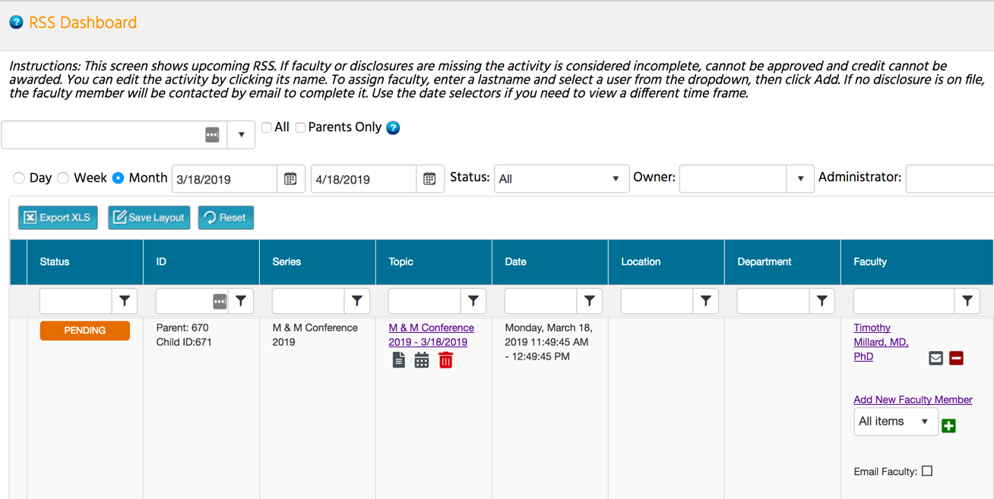

RSS Coordinators/Owners can add additional faculty (faculty not assigned to the RSS parent activity) to the child activity by clicking the Add New Faculty Member link. A new screen will display.

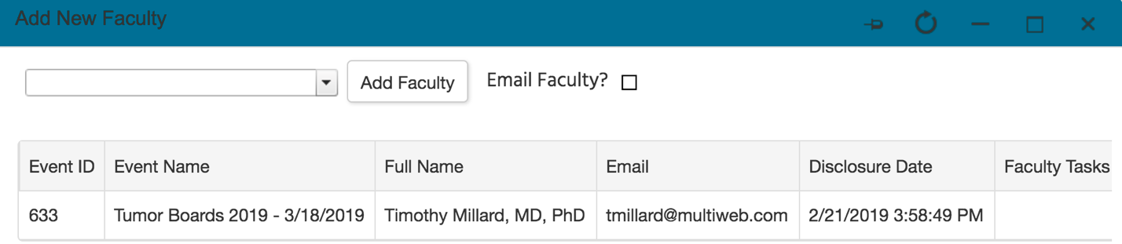

RSS Coordinators/Owners can type in a faculty member’s last name in the search field, select the faculty member to add to the child activity, and click the Add Faculty button.

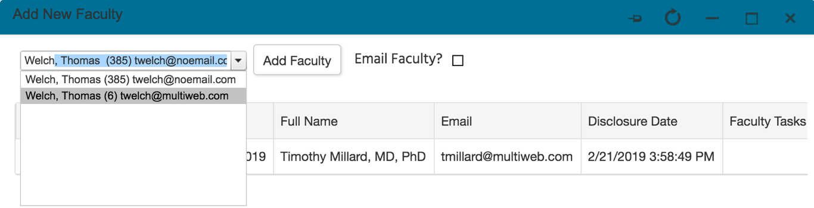

The faculty member will be added to the faculty listing.

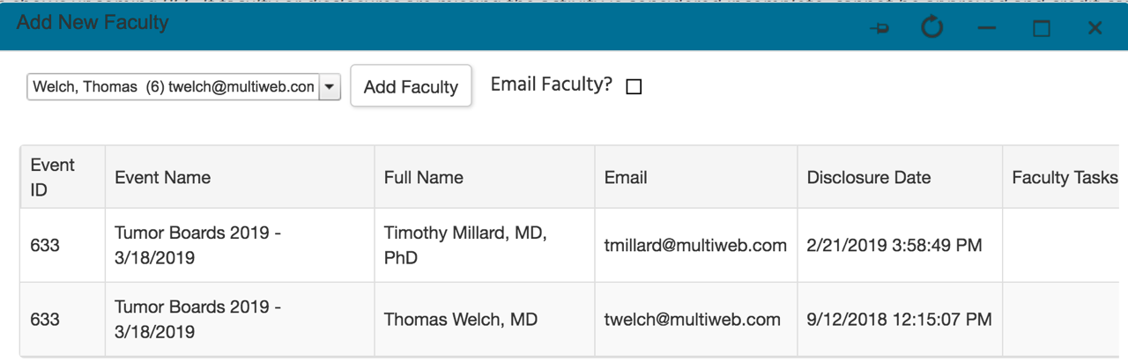

When all faculty have been added to the child activity, click the X in the upper righthand corner of the screen. You will see that the selected faculty member has been added to the child activity on the main RSS Dashboard screen.

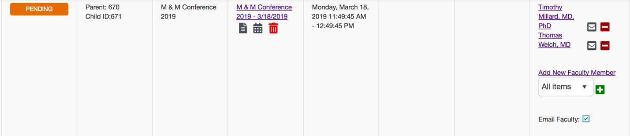

RSS Icons
There are icons in six columns of the RSS Dashboard: Status, Topic, Faculty, Upload Presentation, Disclosure and Notes (Activity Administrators only). Below is the purpose of each icon.
Status column - The status icon. As the planning process continues through the approval state, the icon displayed in this column will continue to update. NOTE: Please refer to the RSS Status Definitions below for a description of each status meaning.
Topic column - Click this icon to generate an activity flyer for distribution or display.
Calendar - Click this icon to display the calendar to view and access the scheduled RSS child activities.
Trash - Click this icon to deactivate an RSS child activity.
Faculty column - This column contains 3 icons. The first is the green plus icon. Once you have selected the faculty member from the dropdown list using last name lookup, click this icon to add the user as a faculty member to the specific RSS child activity.

Once a user has been added as a faculty member, two additional icons display. The first is an Envelope icon. Click this icon and a window will display to create an email message to send to the faculty member. When an email is sent, the system will record this action and place a note on the Notes screen.
Red Minus - Click this icon to remove a faculty member from the RSS child activity.
Disclosure column - The icon will display if the faculty member has not completed their disclosure form.

Upload Presentation column - This icon will display when one or more faculty have disclosed at least one financial relationship in the disclosure form. This icon signals to upload the faculty member's presentation so that the peer review process can begin.
Notes column - The notes column is available to Activity Administrators only. There is a green plus sign located in this column. Click this icon to add notes to the specific RSS child activity.

RSS Status Definitions
Incomplete: This status means that faculty and disclosures have not been assigned yet. RSS Coordinators/Owners will see Incomplete by default until faculty have been assigned and disclosures have been completed. This is the initial default status of every RSS child activity.
Pending: This status represents faculty who have completed a disclosure, and there was no financial relationship declared (i.e. no financial relationships were disclosed, or COI was resolved).
In Review: This status represents faculty who have a completed disclosure and at least one financial relationship has been declared. The faculty member’s presentation has been uploaded, triggering the formal peer review process for potential conflict of interest to determine if resolution is needed.
Approved: This represents faculty who have completed a disclosure, either no financial relationships were declared or, if identified, resolution of conflict of interest has been satisfactorily completed.
Rejected: This represents faculty who have completed a disclosure, a financial relationship has been declared, and the conflict of interest is not able to be satisfactorily resolved. The activity is rejected. The coordinator would remove this faculty member and would need to select a new faculty member and begin the process again.
NOTE: The system will generate an email to the administration email on record when the RSS status changes to Pending if in Administration > Preferences the checkbox "Send email every time an RSS status is pending in the dashboard" is selected. This email will contain a summary of what happened.

COI Resolution Form
In the Forms section, there is a form titled, “COI Resolution.” COI Resolution is triggered when a faculty member has a completed disclosure with at least one financial relationship declared and the faculty member’s presentation has been uploaded for review. This form is automatically assigned to all activities.
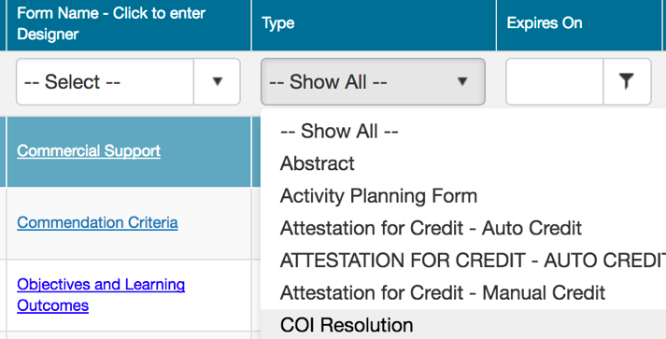

Peer Reviewers (PR)
For the system to trigger the peer review process for Conflict of Interest (COI) Resolution, you can assign users the role of Peer Reviewer. The peer review process is triggered when a faculty member has declared at least one financial relationship, and the faculty member’s presentation has been uploaded for review.
The role of Peer Reviewer (PR) can be assigned through Activities > Activity Manager and selecting the "Owners" tab or through Membership > Membership Manager and selecting the "Roles" tab. If a user has been assigned the role of Peer Reviewer in Activity Manager, the user will be the Peer Reviewer for that specific activity.
If the Peer Reviewer role is not assigned through the Owners tab in Activity Manager, then all users who are assigned the role of Peer Reviewer in Membership Manager will receive an email to complete the peer review process. Therefore, it is a best practice to assign Peer Reviewers in the specific activity.

Activity Manager - Peer Reviewer (Best Practice)
You can assign Peer Reviewer(s) to an activity, so they can review the activity content for potential conflict of interests for resolution. Peer reviewers will have access to the activities which they have been assigned. When presentations are uploaded for an activity, an email will be sent to users set as Peer Reviewers in the Owners tab within Activity Manager. If no users are set on the Owners tab as Peer Reviewers, then the email will go out to all users with the role of Peer Reviewer in Membership Manager.
NOTE: If a Peer Reviewer has been assigned to a parent Regularly Scheduled Series (RSS) activity prior to creating the children, the Peer Reviewer will be copied down to the RSS children.
1. Go to Activities > Activity Manager. Find the specific activity and select the pencil icon to edit.
2. Go to the “Owners” tab and change the default selection to Peer Reviewer by clicking the radio button next to Peer Reviewer.
3. Search for the user to assign the role of Peer Reviewer by last name look-up in the dropdown search box.
4. Click the Add button to add the user as a Peer Reviewer. You will see the user has been added to the table shown below as a Peer Reviewer. PR will appear in the Type column.
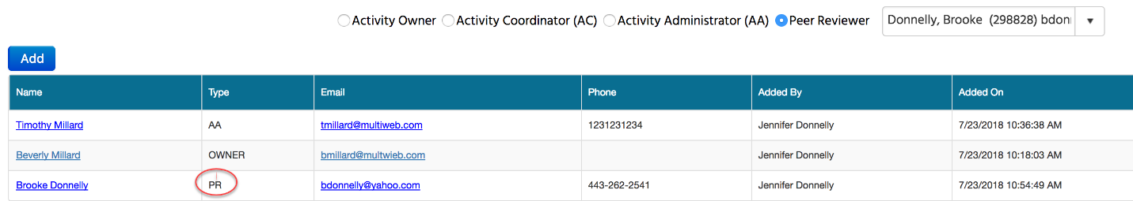

Membership Manager - Peer Reviewer
If the Peer Reviewer role is not assigned through the Owners tab in Activity Manager, then all users who are assigned the role of Peer Reviewer in Membership Manager will receive an email to complete the Peer Review process. Therefore, it is a best practice to assign Peer Reviewers in the specific activity.
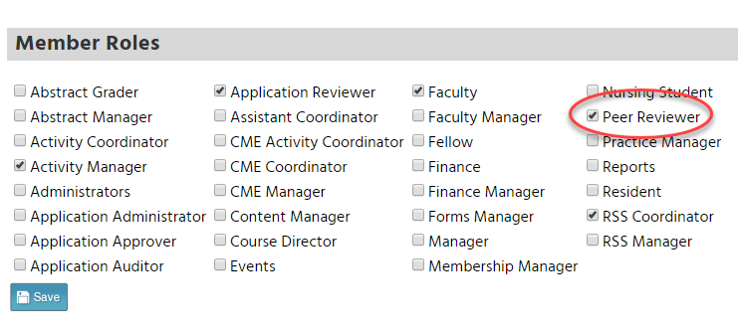

Summary

The RSS Dashboard is designed to bring RSS children (i.e. sessions) together onto one screen making it easy for RSS Coordinators/Owners to focus on just the required items they need to meet full documentation of the activity.

Once this is set-up, it makes administrator’s work easier, by pushing the details out to the coordinator to complete. Ideally, the administrator reviews and approves completed activities.

NOTE: Only approved activities can award SMS text message credits in the system. An unapproved session will not award credits, and users will receive an error message that the activity is unapproved.

